SDV 100-083A: Week 2 – Assignment: Career Exploration

July 30, 2012

Casey Carnnia #6318480

Student

Northern Virginia Community College – Alexandria Campus

For this assignment you will complete an Interest, Values, and Skills Assessment in the Virginia Education Wizard - a one-stop, online resource that provides information and tools about the following areas: assessments, career paths, college curriculum, and financial aid and college costs. The results of the assessment will help you identify possible occupations that match your interests.

Interests Assessment

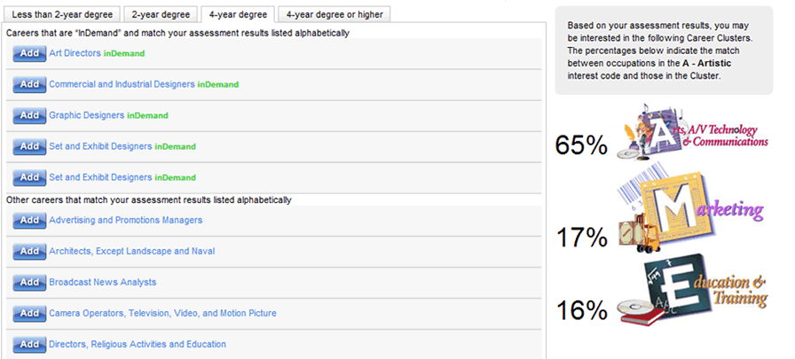

Skill Assessment/



Value Assessment/

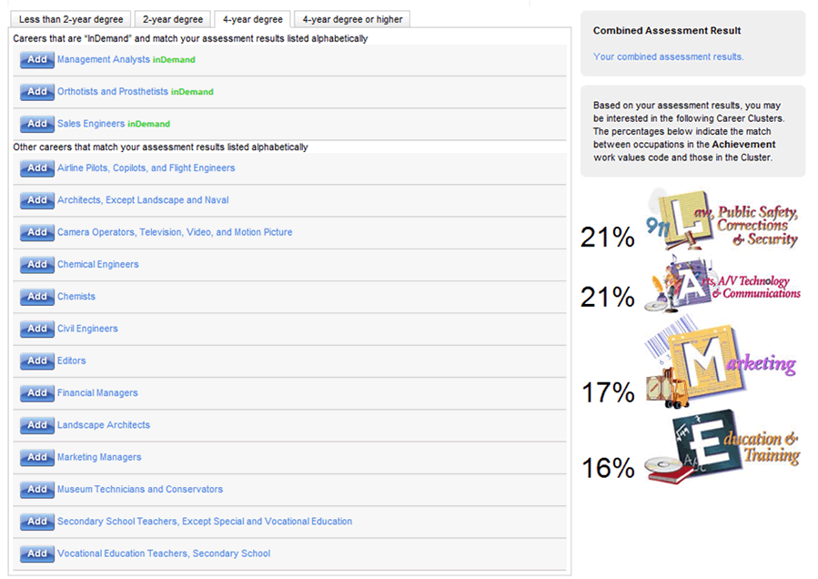

Career Research Chart

|  |  |  |  |  |
| --- | --- | --- | --- | --- |
|  | Career Option #1 | Career Option #2 | Career Option #3 | My Current Job |
| Education & Training Requirement | Art Director | Commercial and Industrial Designer | Graphic Designer | Web Application Developer |
| Primary Work Activity | Thinking Creatively  Interacting With Computers  Making Decisions and Solving Problems | Collecting information  Interacting with computers  Thinking creatively | Thinking Creatively  Collecting Information  Interacting with computers | Collect requirements  Write code  Migrate data  Implement design  Train end users |
| Salary | 121K | 101K | 74K | 77K |
| Additional Areas of Interest | AE  Artistic  Enterprising | AER  Artistic  Enterprising  Realistic | ARE  Artistic  Realistic  Enterprising | CIR  Conventional  Investigative  Realistic |
| Resource Used | O*net Online  CareerInfoNet | O*net Online  CareerInfoNet | O*net Online  CareerInfoNet | O*net Online  CareerInfoNet |
| Notes | I do not disagree. | I do not disagree. | I do not disagree. | I believe my current position reflects my interests and abilities. |